Simple interest program
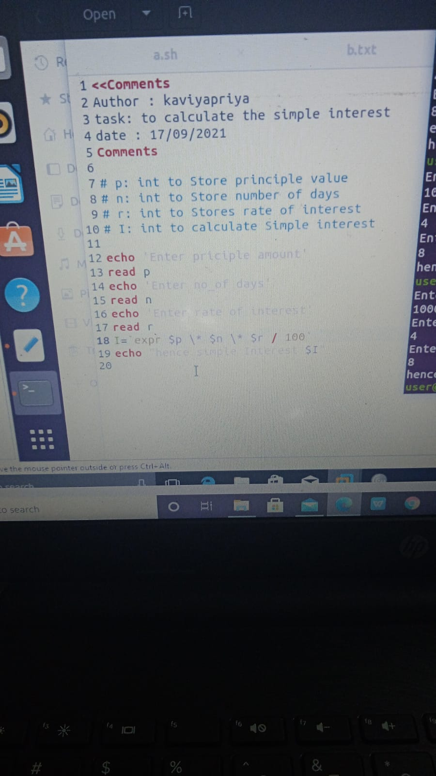

2. Finding circumference of circle
# a : int to store the radius of circle
echo “ Enter the radius of the circle”
read a
cir =`expr 2 \* 3.14 \* $a`
echo “the circumference of circle is $cir”

3. Finding daigonal of rectangle
#b : int to store the breadth of the rectangle
#w : int to store the width of the rectangle
echo “ Enter the breadth”
read b
echo “Enter the width”
read w
d=`expr “$l*$l + $w*$w” | bc`
dai=$(echo “sqrt($d)” | bc)
echo “daigonal is :$dai”
4). Write tables of a number

#n :int stores the number to find the tables

echo “Enter the number to be printed”
read n
for table in ((i=0;i<=10;i++))
do
echo “ $n * $i = $ ( ( n * I ) )”
done
5).Pattern program

*
* *
* * *
* * * *
* * * * *
echo” Enter rows”
read rows
for((i=1; i<=rows; i++))
do
for((j=1; j<=i; j++))
do
echo -n "* "
done
echo
done
6) Number pattern
# start – Starting number
#n no of lines
Start=1
echo “number of lines”
read n
for((i=n;i>=1;i--))
do
for(j=1;j<=i;j++))
do
echo -n “$start”
start=$((start +1))
done
echo
done

